EXPT. NO: 14 | STRUCTURES
DATE: | STRUCTURES
Aim:
To write a C program to compute internal marks of students for five subjects using structures.
Algorithm
- START
- STRUCT student
- Initilize f, s, t, total, avg, internal, assignment in Int
- Declare Variable s[10], s2[10], s3[10], s4[10], s5[10] For Structure
- PRINT Enter Number Of Students:
- GET n
- FOR i = 0 to n
- PRINT Enter Mark For English
- PRINT Enter 3 Cycle Test Mark (Max: 100 Mark):
- GET s[i].f
- GET s[i].s
- GET s[i].t
- COMPUTE s[i].total = s[i].f + s[i].s + s[i].t
- COMPUTE s[i].avg = s[i].total/3
- PRINT Enter Assignment Mark (Max: 10 Mark):
- GET s[i].assignment
- COMPUTE s[i].internal = (s[i].avg * 0.3) + (s[i].assignment*01)
- PRINT Enter Mark For Maths
- PRINT Enter 3 Cycle Test Mark (Max: 100 Mark):
- GET s[i].f
- GET s[i].s
- GET s[i].t
- COMPUTE s[i].total = s[i].f + s[i].s + s[i].t
- COMPUTE s[i].avg = s[i].total/3
- PRINT Enter Assignment Mark (Max: 10 Mark):
- GET s[i].assignment
- COMPUTE s[i].internal = (s[i].avg * 0.3) + (s[i].assignment*01)
- PRINT Enter Mark For Physics
- PRINT Enter 3 Cycle Test Mark (Max: 100 Mark):
- GET s[i].f
- GET s[i].s
- GET s[i].t
- COMPUTE s[i].total = s[i].f + s[i].s + s[i].t
- COMPUTE s[i].avg = s[i].total/3
- PRINT Enter Assignment Mark (Max: 10 Mark):
- GET s[i].assignment
- COMPUTE s[i].internal = (s[i].avg * 0.3) + (s[i].assignment*01)
- PRINT Enter Mark For Chemistry
- PRINT Enter 3 Cycle Test Mark (Max: 100 Mark):
- GET s[i].f
- GET s[i].s
- GET s[i].t
- COMPUTE s[i].total = s[i].f + s[i].s + s[i].t
- COMPUTE s[i].avg = s[i].total/3
- PRINT Enter Assignment Mark (Max: 10 Mark):
- GET s[i].assignment
- COMPUTE s[i].internal = (s[i].avg * 0.3) + (s[i].assignment*01)
- PRINT Enter Mark For CS
- PRINT Enter 3 Cycle Test Mark (Max: 100 Mark):
- GET s[i].f
- GET s[i].s
- GET s[i].t
- COMPUTE s[i].total = s[i].f + s[i].s + s[i].t
- COMPUTE s[i].avg = s[i].total/3
- PRINT Enter Assignment Mark (Max: 10 Mark):
- GET s[i].assignment
- COMPUTE s[i].internal = (s[i].avg * 0.3) + (s[i].assignment*01)
- FOR i = 0 to n
PRINT Student [i+1] Got [s[i].internal] Marks in Engilish [s2[i].internal] Marks in Maths s3[i].internal Marks in Physics [s4[i].internal] Marks in Chemistry [s5[i].internal] Marks in CS \n"
Program
#include<stdio.h>
#include<stdlib.h>
struct student {
int f, s, t, total, avg, internal, assignment;
};
struct student s[10], s2[10], s3[10], s4[10], s5[10];
int main() {
int n, i;
printf("Enter Number Of Students: ");
scanf("%d", &n);
for(i = 0; i < n; i++) {
printf("\t\tEnter Mark For English\t\t\n");
printf("Enter 3 Cycle Test Mark (Max: 100 Mark): ");
scanf("%d %d %d", &s[i].f, &s[i].s, &s[i].t);
s[i].total = s[i].f + s[i].s + s[i].t;
s[i].avg = s[i].total/3;
printf("Enter Assignment Mark (Max: 10 Mark): ");
scanf("%d", &s[i].assignment);
s[i].internal = (s[i].avg * 0.3) + (s[i].assignment*01);

printf("\t\tEnter Mark For Maths\t\t\n");
printf("Enter 3 Cycle Test Mark (Max: 100 Mark): ");
scanf("%d %d %d", &s2[i].f, &s2[i].s, &s2[i].t);
s2[i].total = s2[i].f + s2[i].s + s2[i].t;
s2[i].avg = s2[i].total/3;
printf("Enter Assignment Mark (Max: 10 Mark): ");
scanf("%d", &s2[i].assignment);
s2[i].internal = (s2[i].avg * 0.3) + (s2[i].assignment*01);

printf("\t\tEnter Mark For Physics\t\t\n");
printf("Enter 3 Cycle Test Mark (Max: 100 Mark): ");
scanf("%d %d %d", &s3[i].f, &s3[i].s, &s3[i].t);
s3[i].total = s3[i].f + s3[i].s + s3[i].t;
s3[i].avg = s3[i].total/3;
printf("Enter Assignment Mark (Max: 10 Mark): ");
scanf("%d", &s3[i].assignment);
s3[i].internal = (s3[i].avg * 0.3) + (s3[i].assignment*01);

printf("\t\tEnter Mark For Chemistry\t\t\n");
printf("Enter 3 Cycle Test Mark (Max: 100 Mark): ");
scanf("%d %d %d", &s4[i].f, &s4[i].s, &s4[i].t);
s4[i].total = s4[i].f + s4[i].s + s4[i].t;
s4[i].avg = s4[i].total/3;
printf("Enter Assignment Mark (Max: 10 Mark): ");
scanf("%d", &s4[i].assignment);
s4[i].internal = (s4[i].avg * 0.3) + (s4[i].assignment*01);

printf("\t\tEnter Mark For CS\t\t\n");
printf("Enter 3 Cycle Test Mark (Max: 100 Mark): ");
scanf("%d %d %d", &s5[i].f, &s5[i].s, &s5[i].t);
s5[i].total = s5[i].f + s5[i].s + s5[i].t;
s5[i].avg = s5[i].total/3;
printf("Enter Assignment Mark (Max: 10 Mark): ");
scanf("%d", &s5[i].assignment);
s5[i].internal = (s5[i].avg * 0.3) + (s5[i].assignment*01);
}
for(i = 0; i < n; i++) {
printf("Student %d Got %d Marks in Engilish %d Marks in Maths %d Marks in Physics %d Marks in Chemistry %d Marks in CS \n", i+1, s[i].internal, s2[i].internal, s3[i].internal, s4[i].internal, s5[i].internal);
}
}
Output
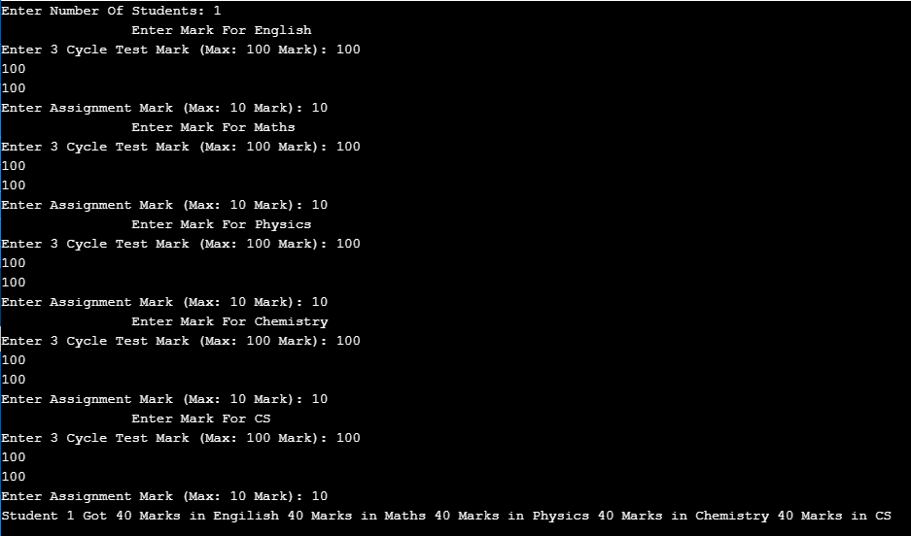
Result
Thus the C program to compute internal marks of students for five subjects using structure was executed successfully.

